NAME………………………………………………………………ADM NO……...CLASS..…
232/1 Candidate’s Signature….…….
Physics
Paper 1 Date……………………………
2 hours

PANGANI GIRLS’ HIGH SCHOOL
POST MOCK 2019
Kenya Certificate of Secondary Education (KCSE)
September 2019
PHYSICS
Paper 1
2 hours
Instructions to candidates
- Write your name and class in the space provided.
- This paper consists of two sections; SECTION A and B
- Answer all the questions in the spaces provided
- ALL working MUST be clearly shown.
- Mathematical tables and electronic calculators may be used
- Take: Acceleration due to gravity: g = 10m/s²
Candidates should check the question paper to ascertain that all the pages are printed as indicated and that no questions are missing.
For Examiner’s Use Only
Section | Question | Maximum Score | Candidate’s Score
A | 1 – 12 | 25
B | 13 | 10
 | 14 | 11
 | 15 | 12
 | 16 | 10
 | 17 | 12
 | Total Score | 80

SECTION A (25 MARKS)
- With a reason identify in which state isdiffusion faster between gasand liquid. (2marks)
…………………………………………………………………………………………………………………………………………………………………………………………………………………………………………………………………………………………………………………………………………………………………………………………………………………………………………………..
- The length of the spring is 20.0cm. It becomes 24.0cm when a weight of 8.0N hangs on it. Calculate the length of the spring when supporting a weight of 200N. (2marks)
…………………………………………………………………………………………………………………………………………………………………………………………………………………………………………………………………………………………………………………………………………………………………………………………………………………………………………………..
- The figure below shows the instrument used to measure pressure

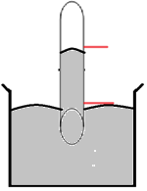
Mercury
X
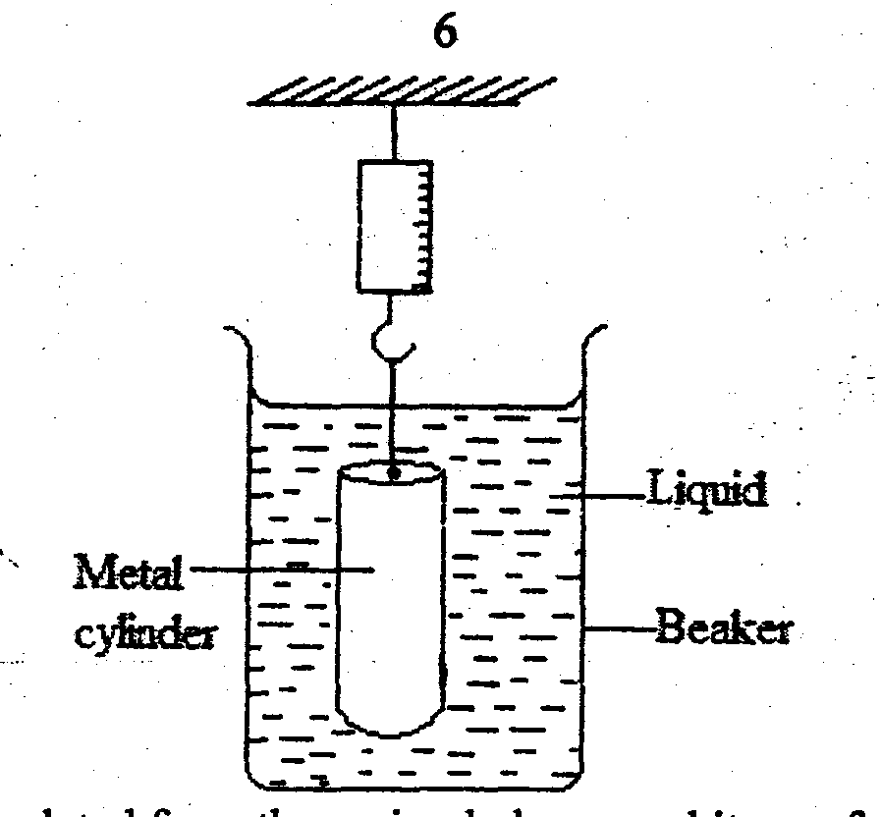

  - Name the instrument (1mark)
……………………………………………………………………………………………………………..
  - What would be observed if the test tube is tilted assuming the instrument is functioning normally (1mark)
…………………………………………………………………………………………………………………………………………………………………………………………………………………………

- The rate of heat flow in thermal conductivity increases with increase in cross-section area. Explain this observation (1mark)
…………………………………………………………………………………………………………………………………………………………………………………………………………………………………………………………………………………………………………………………………………………………………………………………………………………………………………………..
- Explain why a small car travelling at a very high speed is likely to be dragged into a long track travelling in the opposite direction (2marks)
…………………………………………………………………………………………………………………………………………………………………………………………………………………………………………………………………………………………………………………………………………………………………………………………………………………………………………………..
- A uniform meter rule is balanced by two masses as shown in the figure below.
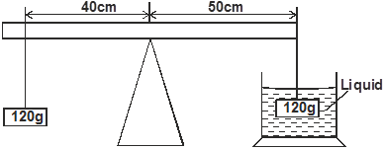

125g

By displacement method, the immersed object is found to occupy 13.5cm³. Determine the density of the liquid in SI units. (3 marks)

- The springs shown in the arrangement in figure 4 below are identical.

180N

Given that the 180N weight causes a total extension of 30cm, determine the spring constant of each spring. (The weight of each spring is negligible)
(3 marks)

- i) Distinguish between elastic collision and inelastic collision. (1 mark)

………………………………………………………………………………………………………………………………………………………………………………………………………………………………………………………………………………………………………………………………………
ii) State the energy transformation during inelastic collision. (2 marks)
…………………………………………………………………………………………………………………………………………………………………………………………………………………………………………………………………………………………………………………………………………………………………………………………………………………………………………………..
- State the branch of physics that deal with kinetic energy of matter. (1 mark)

…………………………………………………………………………………………………………………………………………………………………………………………………………………………………………………………………………………………………………………………………………………………………………………………………………………………………………………..

- The water in a burette is 30.6cm³, 50 drops of water each of volume V are added to the water in the burette. The final reading of the burette was 20.6cm³. Calculate the radius of the drop of water .
(3 marks)

- State two factors that affect the stability of an object (2 marks)

………………………………………………………………………………………………………………………………………………………………………………………………………………………………………………………………………………………………………………………………………
- State a reason why a burn from steam at 100⁰cis more severe than a burn from boiling water at the same temperature (1 mark)
………………………………………………………………………………………………………………………………………………………………………………………………………………………………………………………………………………………………………………………………………
SECTION B: (55 MARKS)

- a) An astronaut in orbit round the earth may feel weightless even when the earth’s gravitational field still acts on him. Explain (2 marks)

…………………………………………………………………………………………………………………………………………………………………………………………………………………………………………………………………………………………………………………………………………………………………………………………………………………………………………………..
b) Distinguish between angular velocity and linear velocity (1 mark)
…………………………………………………………………………………………………………………………………………………………………………………………………………………………………………………………………………………………………………………………………………………………………………………………………………………………………………………..

c) a stone is whirled with uniform speed in a horizontal circle of radius 15 cm. it takes the stone 10 seconds to describe an arc of length 4cm. calculate
i) Angular velocity (3 marks)

ii) Linear velocity of the stone (2 marks)

iii) Periodic time (2 marks)

- a) State the Bernoulli’s principle of fluids (2 marks)

…………………………………………………………………………………………………………………………………………………………………………………………………………………………………………………………………………………………………………………………………………………………………………………………………………………………………………………..
b) In derivation of equation of continuity in fluids, state two assumptions to be made. (2marks)

…………………………………………………………………………………………………………………………………………………………………………………………………………………………………………………………………………………………………………………………………………………………………………………………………………………………………………………..

b) The figure below shows cross-section of two submerged bodies P and Q in an ocean. The bodies were then pulled by a ship in the direction shown.

Q
P

- State with a reason, which body is easier to pull if they have equal volume and density (2 marks)
…………………………………………………………………………………………………………………………………………………………………………………………………………………………………………………………………………………………………………………………………………………………………………………………………………………………………………………..

- On the same diagram, show the path followed by each body and their streamlines (2 marks)

c) Water flows steadily a pipe as shown in the figure below. The diameter of A and B are 3cm
and 5cm. if the volume flux at A is 45cm³/s. find the speed of water at B.(3 marks)
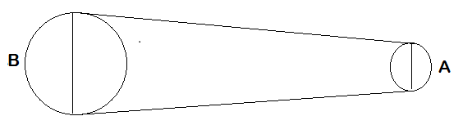

- a) State the law of floatation (1 mark)

………………………………………………………………………………………………………………………………………………………………………………………………………………………………………………………………………………………………………………………………………

b) The diagram below shows a hot air balloon tethered to the ground on a calm day. The balloon contains 1300cm³ of hot air of density 0.82 kg/m3. The mass of the material making the balloon without hot air is 420kg. The density of the surrounding air is 1.35 kg/m³. Determine
Hot air

i) The total weight of hot air balloon (3 marks)

- The weight of air displaced by the balloon (2 marks)

- Upthrust force on the balloon (1 mark)

- the tension in the rope holding the balloon in the ground. (2 marks)

- the acceleration with which the balloon begins to raise when released.(3marks)

- a) the graph below represents a body moving with variable speed

Displacement
(m)

Time (s)

on the same graph sketch the results of the same body moving at a lower velocity.(1 marks)
b) A paper tape was attached at a moving trolley and allowed to run throw a ticker timer. If the frequency of the tape is 100Hz. Determine

. . . . . . . . . . . . . . .
1.5 cm
3.2 cm
A
B
D
C

i)The period of the ticker timer (2 marks)

ii)Velocity AB and CD (4 marks)

ii)The average acceleration (3 marks)

- a)Figure 9 shows a set up to investigate one of the gas laws. All equipment are standardized.
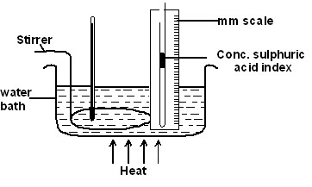
Thermometer

i) Name the gas law being investigated. (1 mark)
……………………………………………………………………………………………………………
ii) Give two reasons for using the concentrated sulphuric acid index. (2 marks)
…………………………………………………………………………………………………………………………………………………………………………………………………………………………………………………………………………………………………………………………………………………………………………………………………………………………………………………..

iii) What is the purpose of the water bath? (1 mark)
…………………………………………………………………………………………………………………………………………………………………………………………………………………………
iv) State two measurements that should be taken in this experiment. (2 marks)
…………………………………………………………………………………………………………………………………………………………………………………………………………………………
v) Explain how the measurements taken in (iv) above may be used to verify the law. (3 marks)
…………………………………………………………………………………………………………………………………………………………………………………………………………………………………………………………………………………………………………………………………………………………………………………………………………………………………………………..

b) A gas has a volume of 30cm³ at 18ºC and normal atmospheric pressure. Calculate the new volume of the gas if it is heated to 54ºC at the same pressure. (3 marks)

